**Forthing Friday REEV**

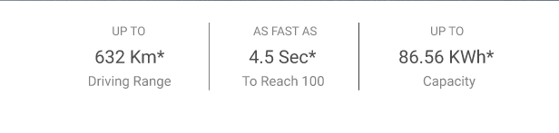

Upto

1150 Km*

Driving Range

AS FAST AS

10.9 Sec

To Reach 100

Upto

31.94kWh

Capacity

____________________ Color Selection _________________

Available color

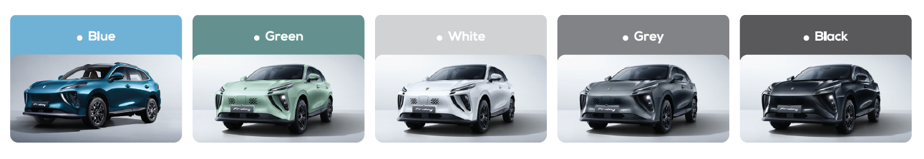

____________________ Advanced Driving Dynamics _________________

1. This will be first

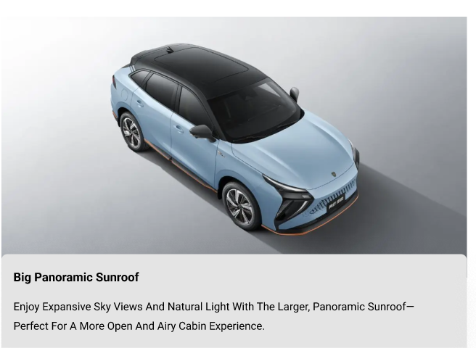

1. This is okay and will be in second position

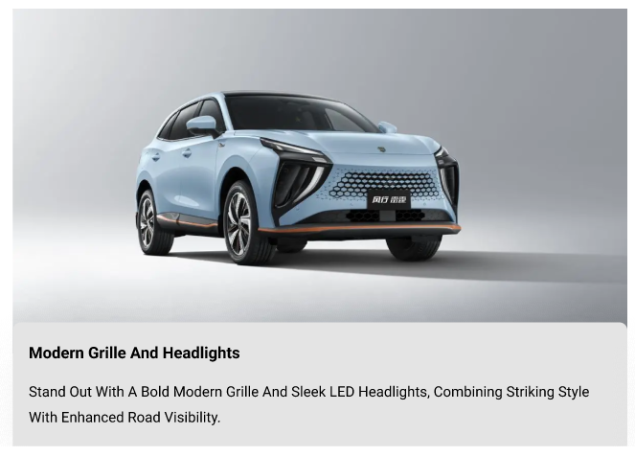

1. This will be at 3rd position

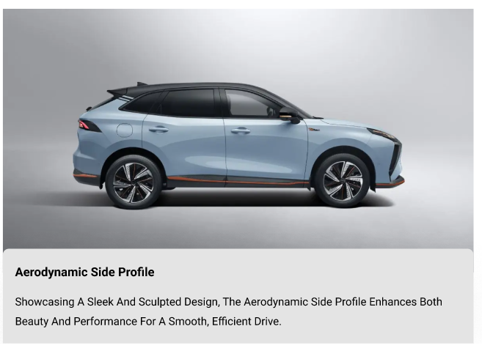

1. **Sport-Tuned Alloy Wheels**

Sport-tuned alloy wheels enhance both style and performance. Designed for stability and sharp handling, they add a bold, athletic edge to every drive.


        FORTHING T5 FRIDAY 2024 full         

1. **LED Matrix Headlights & Tail Lamps**

LED matrix headlights and tail lamps offer superior visibility and a modern look. They adapt intelligently to driving conditions, improving safety while enhancing the vehicle's futuristic style.

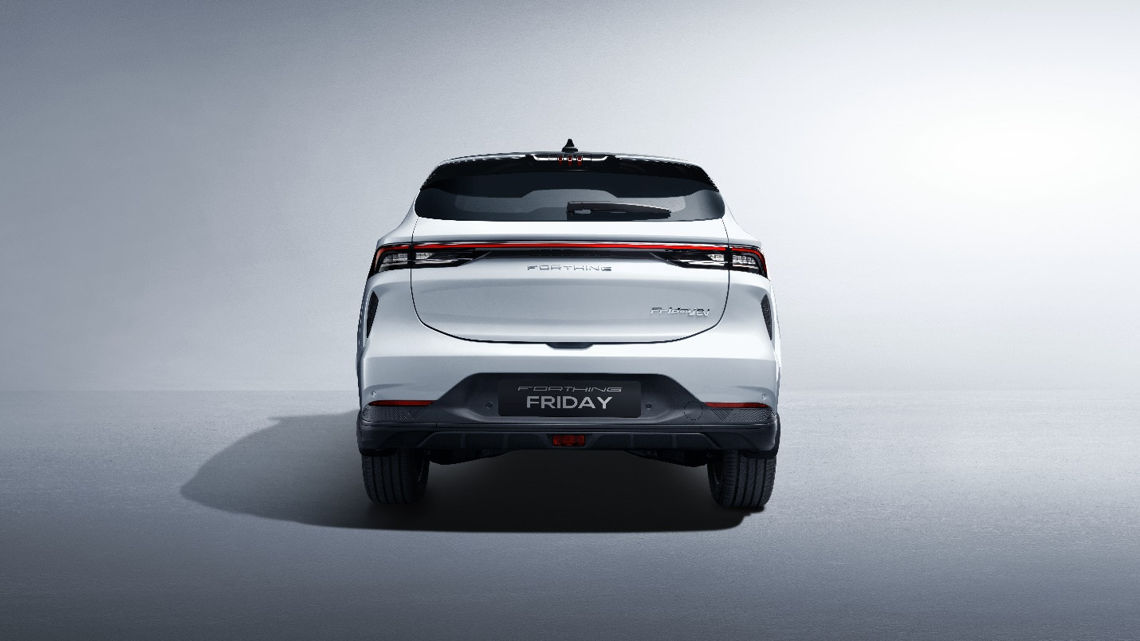

____________________ Exterior Features _________________

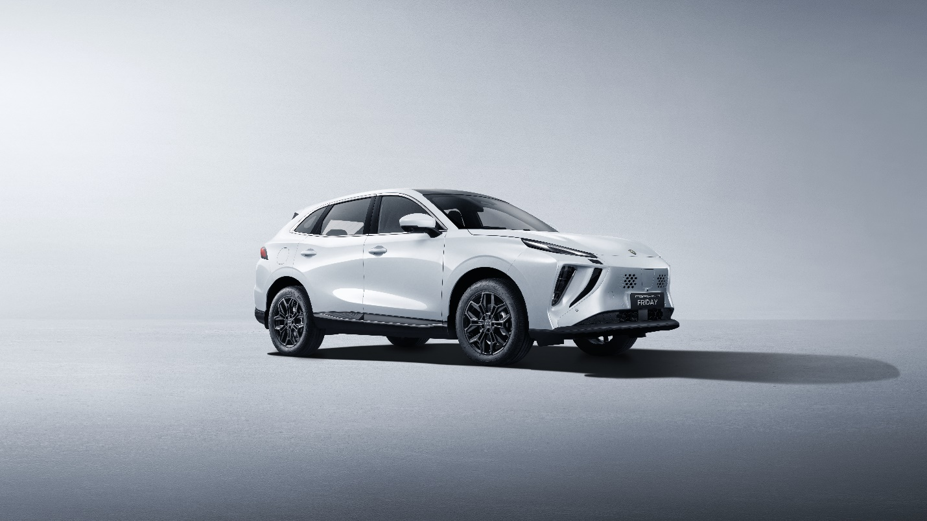

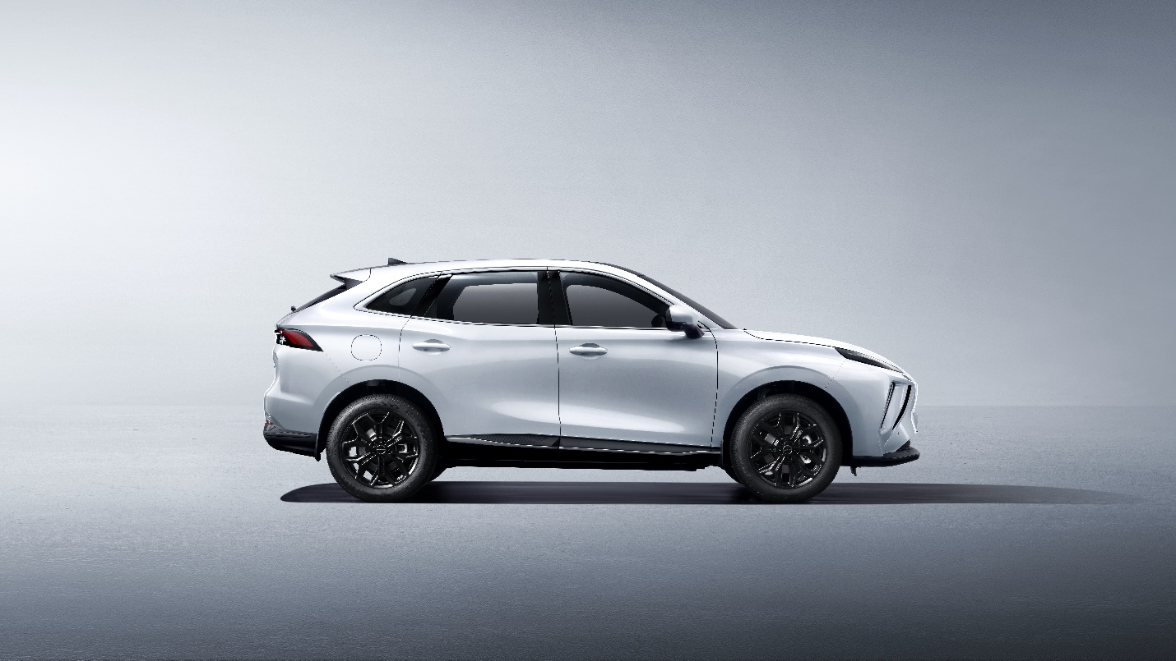

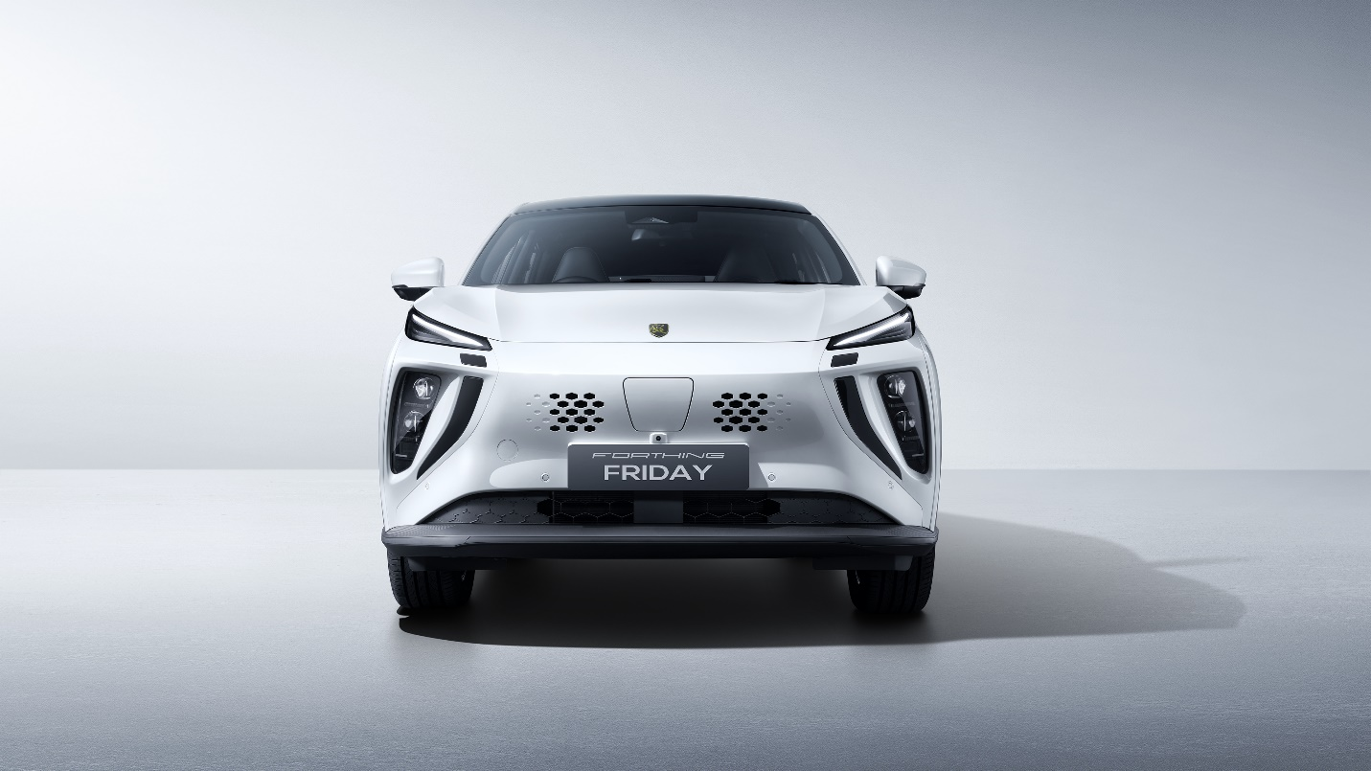

____________________ Interior Features_________________

1. **SMART HOME SPACE**

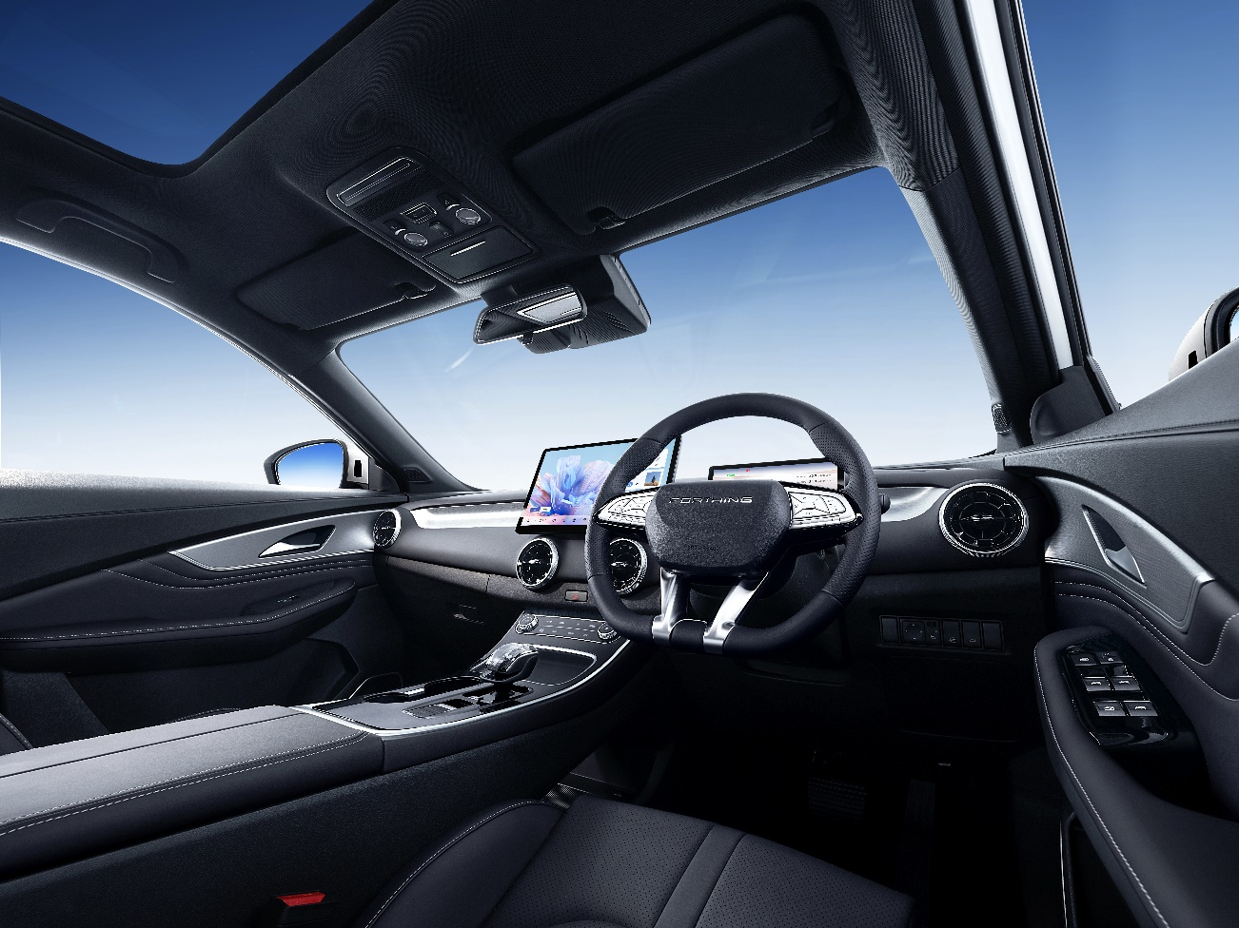

Step into a roomy, tech-savvy cabin where comfort and innovation come together.

Thoughtfully designed for you, the open interior offers maximum space and ease.

Smart features throughout make every drive smooth, connected, and refined.

1. ERGONOMIC SEATS

WITH LEATHER & VENTILATION OPTIONS

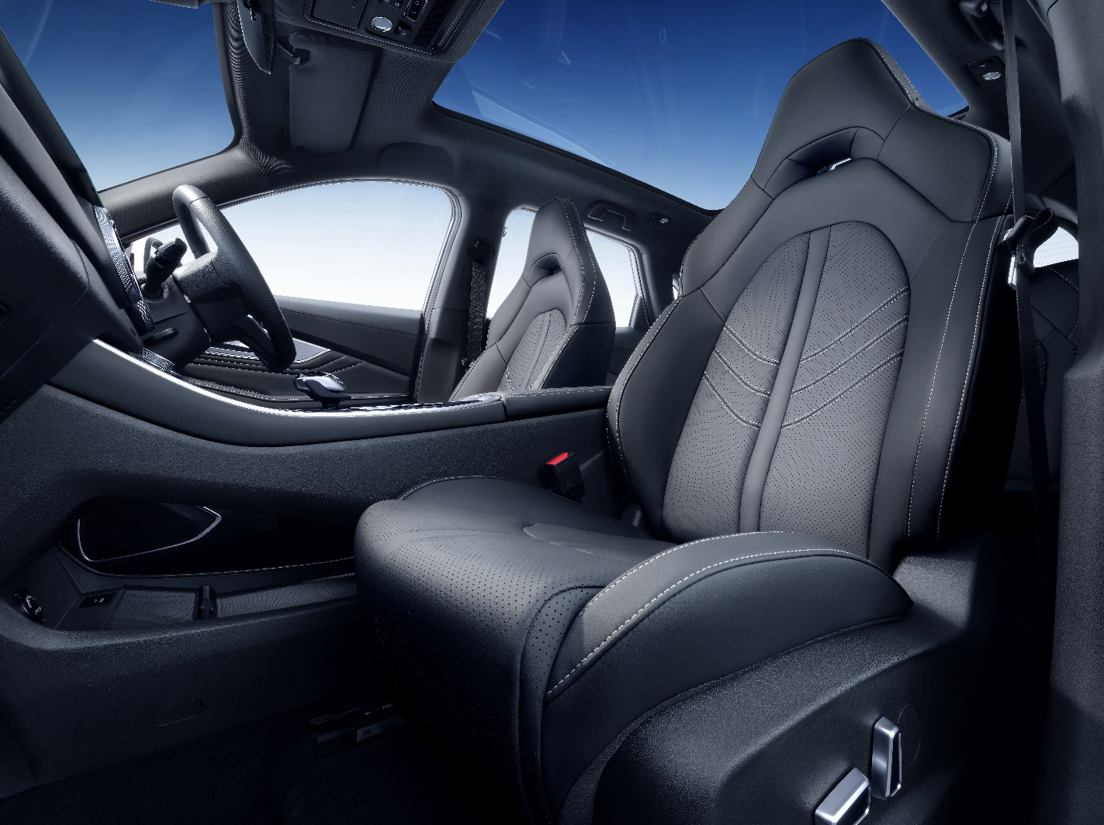

Designed for optimal comfort and support, the seats feature high-quality leather finishes and optional ventilation to enhance the driving experience in all conditions.

1. Dual HD screens: infotainment + digital cluster

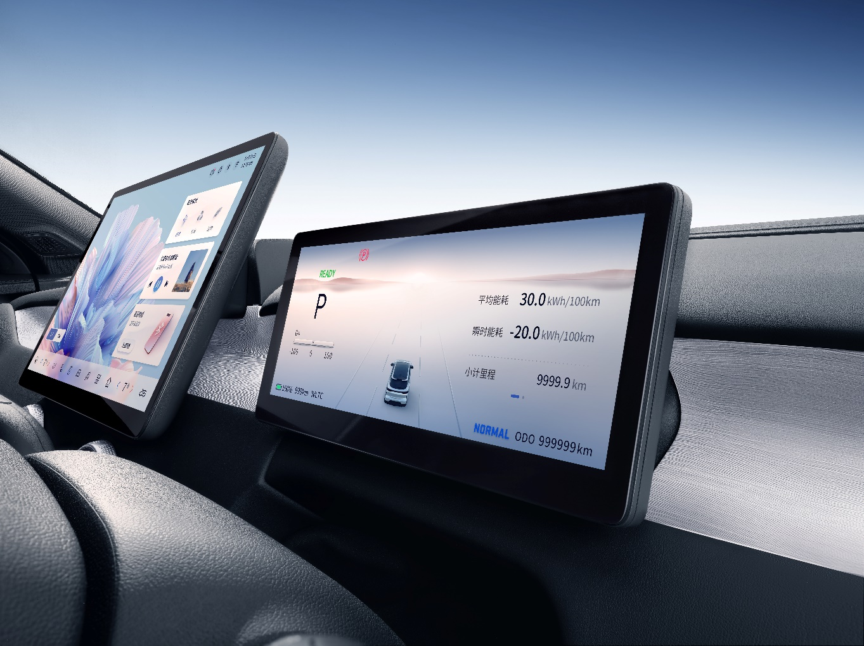

Features a high-resolution infotainment touchscreen paired with a fully digital instrument cluster, delivering clear visuals, intuitive control, and a connected driving experience.

1. Shift Electronic Gear Shifting Technology.

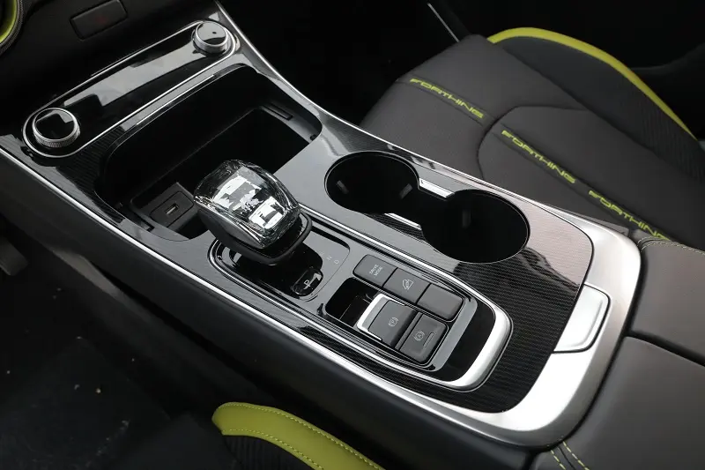

Experience seamless control with advanced electronic gear shifting for a sleek, modern drive.

1. Spacious trunk with split-folding rear seats

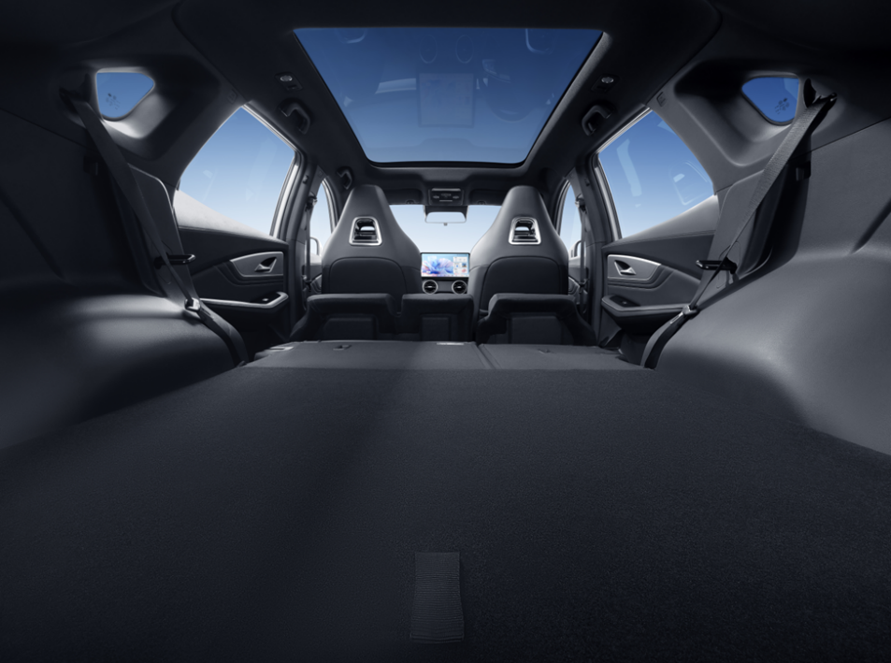

Spacious trunk with split-folding rear seats offers flexible storage for all your adventures.

____________________ Safety Features_________________

1. **ADAS Advanced Driver Assistance System**

ADAS (Advanced Driver Assistance System) enhances safety with intelligent features like lane keeping, collision warning, and adaptive cruise control for a smarter, more secure drive.

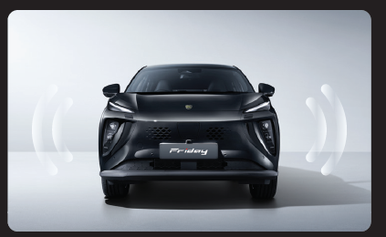

1. AEB Autonomous Emergency Braking

It automatically detects obstacles and applies the brakes to help prevent or reduce the severity of collisions, ensuring greater safety on the road.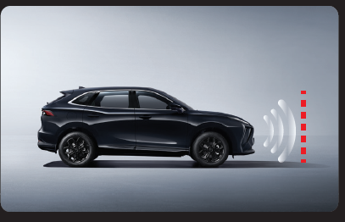

1. Lane Keep Assist Adaptive Cruise Control

maintains a set speed while automatically adjusting to the flow of traffic, ensuring a smooth and safe driving experience.

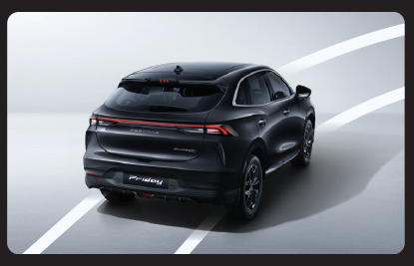

6-Airbag Protection System

Forthing Friday comes with comprehensive safety with front, side, and curtain airbags, shielding occupants from multiple angles in the event of a collision.

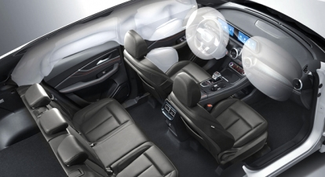

1. 360° Surround View Camera

360° Surround View Camera delivers a real-time bird’s-eye view of your surroundings, making parking and maneuvering in tight spaces safer and easier.

